**Algorithms and Data Structures – 2**

**Module-1 Activity 15**

1. Implement the following DFS paths API.

Finding paths: It is easy to modify depth-first search to not only determine whether there exists a path between two given vertices but to find such a path (if one exists). We seek to implement the following API:

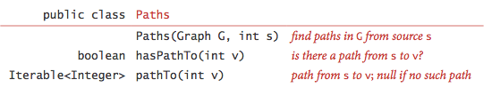

Check for the sample Input and output in the given folder.